Create table GUI

1)Modeler perspective

2)schema- trainee04-newtable

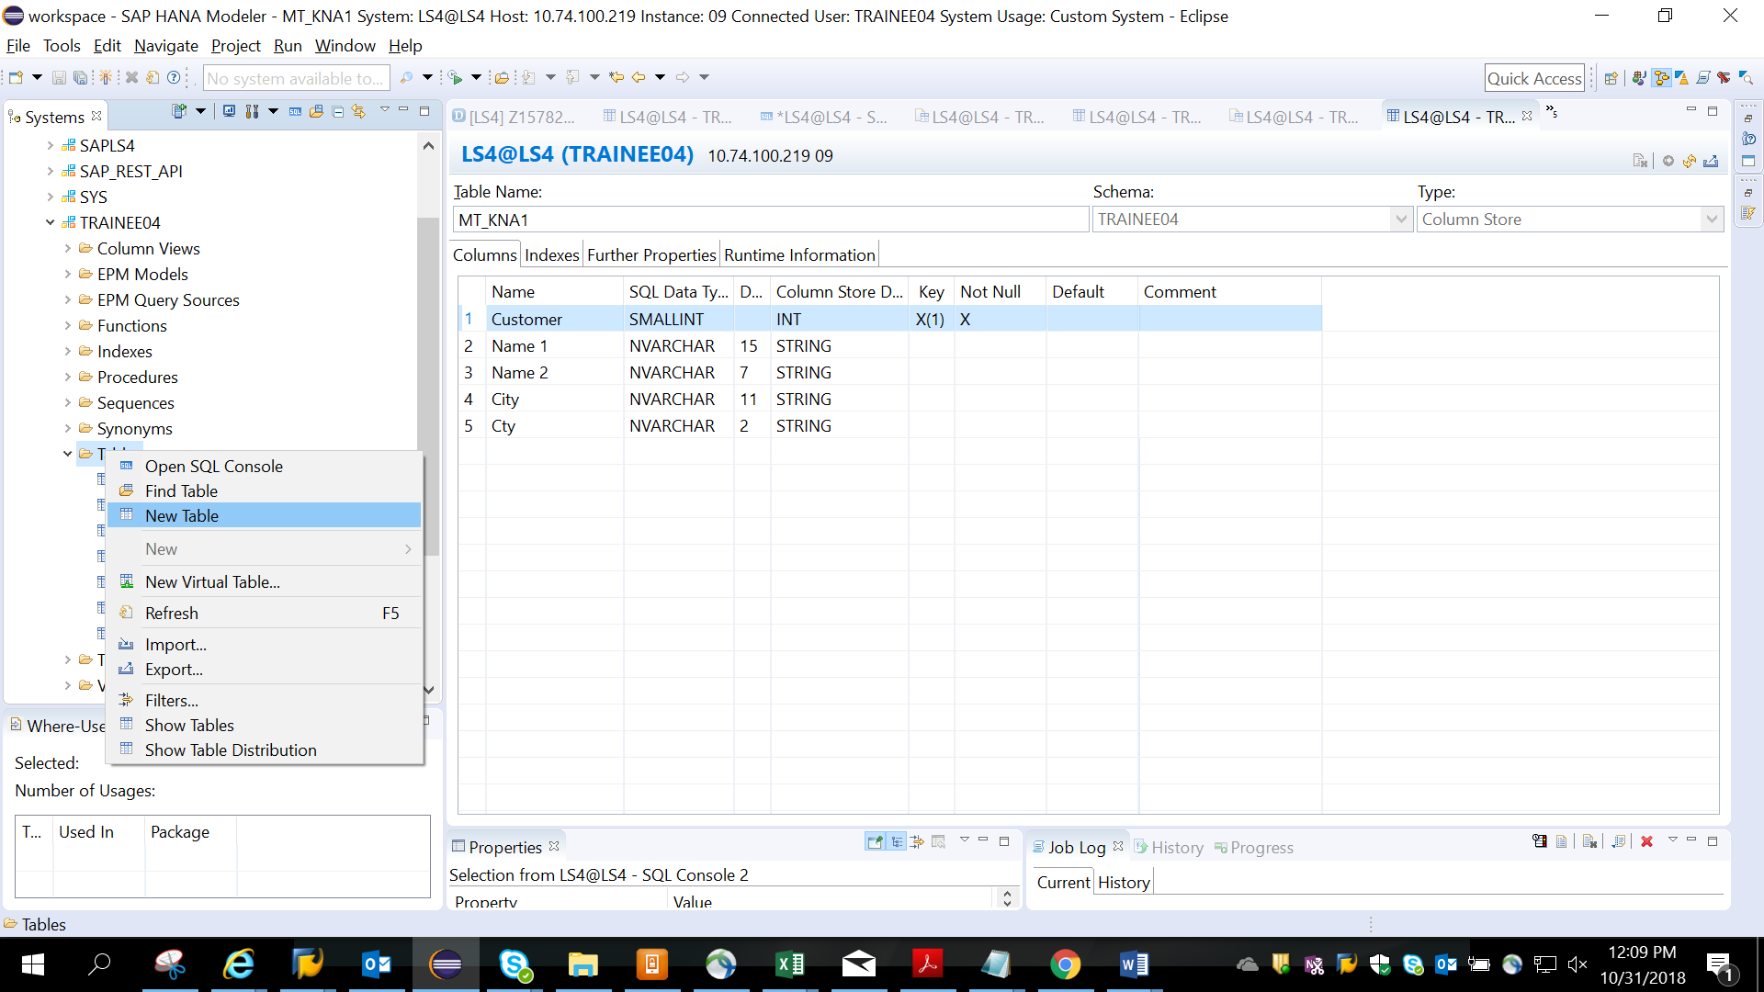

Fill in the column names and data types

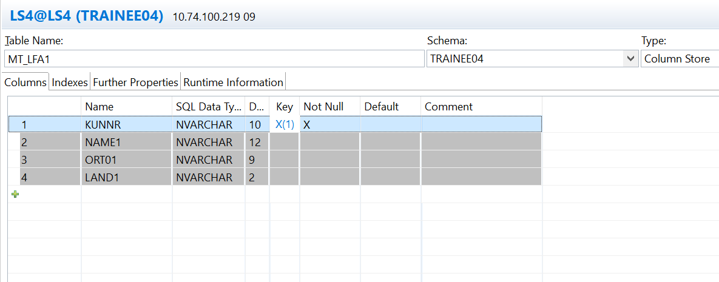

Click on create button /execute

Check if the table is created in catalog-TRAINEE04-tables-MT_LFA1

